Newsletter – October 2025

Welcome to the second Little Explorers newsletter – we will send these termly to let you know about the wonderful experiences the children have been having in nursery, any important messages, things to look forward to and our achievements.
Although we share a lot of information through the app and on social media, the aim of this message is to help strengthen parent relationships. We hope you enjoy learning more about our setting.

A new school year!
A warm welcome to our new families and hello to our returning children and also siblings – it’s great to have you all on board and see how well you’ve settled into your school nursery and our settings.
It’s always a big step and this term is challenging with so many transitions and the changing seasons, but we will be here to help support you as much as we can.

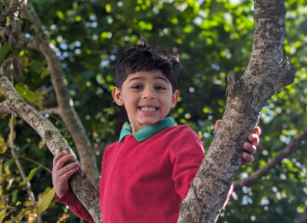
A new chapter for us
At the end of last term, we found out that we were able to open a second setting in Llanedeyrn Primary school.
Having opened Little Explorers initially as a childminding setting in 2015, we have grown so much & this is now our second childcare setting
We spent all of August getting the premises ready to open in September, which was quite a challenge!
We hope you enjoy your new classes at school and are making lots of new friends.
r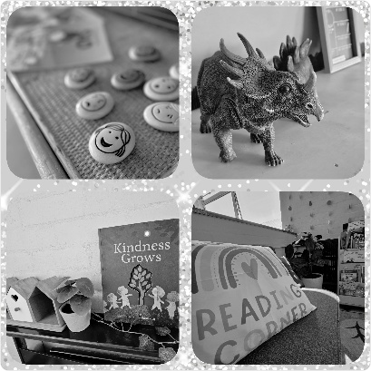

Thank you to all who helped dig, paint, scrub and build to get the nursery ready and welcome to our new families over in Cardiff East.
We will be based in Llanedeyrn for the whole of October half term so the children will have the opportunity to explore the place all week.

Launch of recipe book 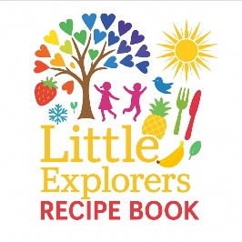
We have been busy behind the scenes collecting the children’s favourite recipes to produce a mini booklet. We will add this to the website parent portal and email a copy. We hope you enjoy trying some out at home. We are always keen to hear what foods your children really enjoy so welcome any suggestions and recommendations.

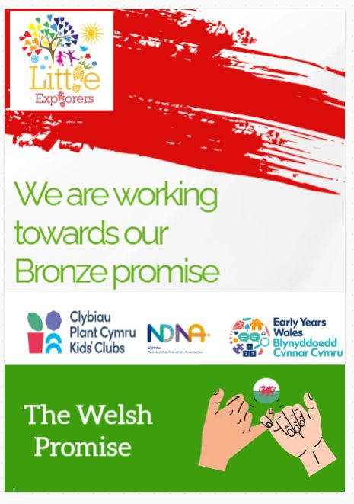
We are working towards our Bronze level Welsh Promise with NDNA Cymru. This has meant increasing the Welsh signage in the setting and promoting Welsh language opportunities by ensuring more activities include the Welsh language.
We are also working to embrace and celebrate the Welsh language and culture & we join regularly with NDNA for singing and story time in Welsh.
We’re sure the children from Berllan Deg will help us improve our pronunciation.

A look back over the Summer
We enjoyed a warm Summer which allowed us to spend even more time outdoors. We planted a lot of flowers, fruits and herbs which we enjoyed in nursery.
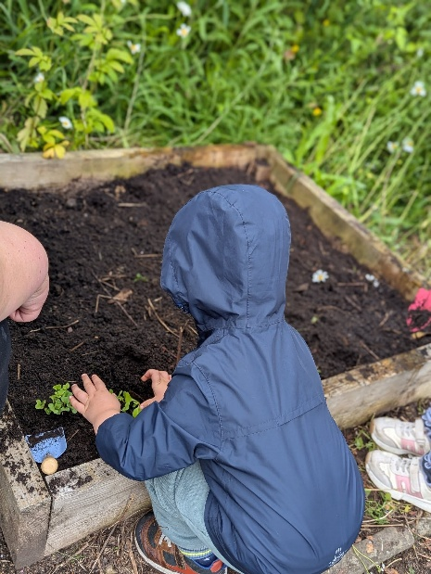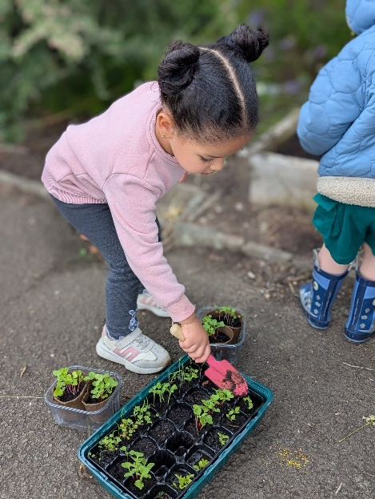

June brings the challenge of 30 Days Wild with the Wildlife Trust. This is a highlight of our year and presents so many opportunities to connect with nature.
This year we enjoyed a sunflower growing competition, nature tables, picnics, bee bombs, sensory playdough, yoga and flower potions as well as so many more.

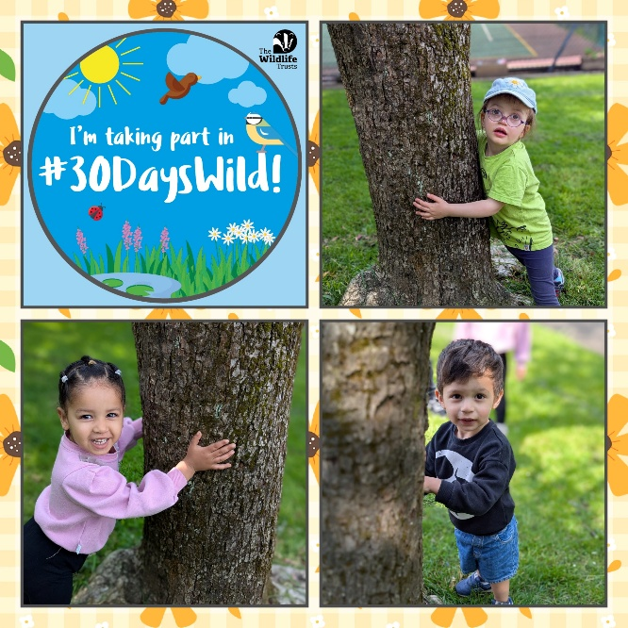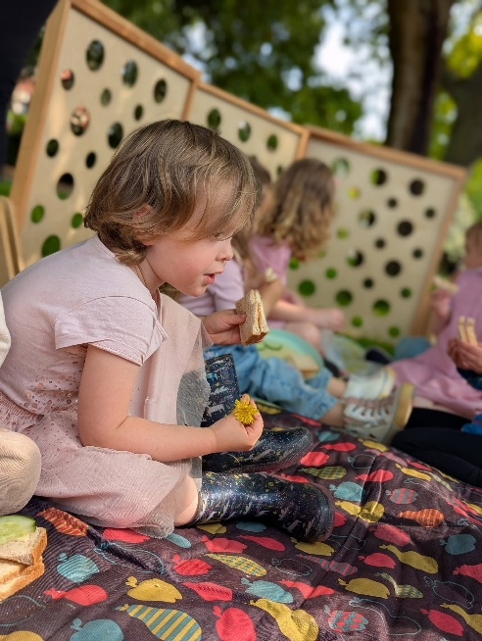

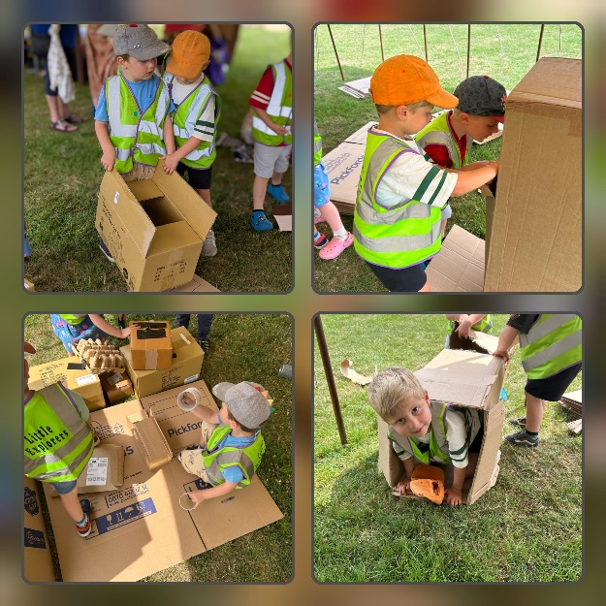
We joined with hundreds of other children to celebrate National Play Day at Eastern Leisure Centre.
This event is co-ordinated by Playboard Northern Ireland, Play Scotland, Play England, and Play Wales.
We celebrate Playday each year to show why play is vital for children’s health, well-being and development. It also highlights how important it is that children enjoy their childhood.

As part of our celebration of East Asian Week we visited the Shree Swaminarayan Temple to learn more about Hinduism. We were able to view the Murtis of the different gods and learn about their stories, we took part in some yoga and tried traditional foods and dress.
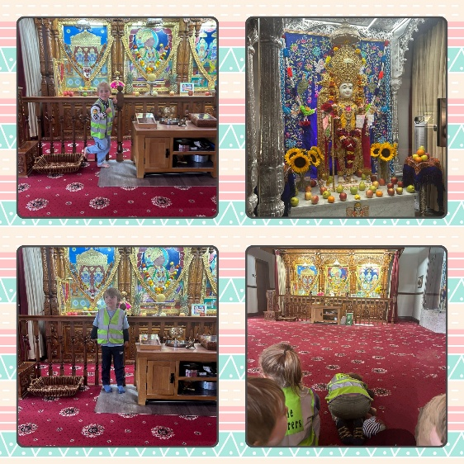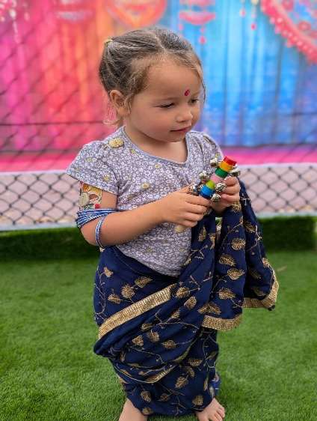

Staff news
Millie has recently joined the team, she is a fully qualified Early Years teacher and is working with the pre-school group, helping them breach the gap between school and nursery and is helping guide our planning provision with the new curriculum.

Laura renewed her Fire Warden training, Sam renewed her Level 2 Food Hygiene certificate, Tabitha updated her Prevent knowledge and Tamar successfully reaccredited her Paediatric First Aid training.

Important dates
As the days get shorter and the weather turns colder, we look forward to getting cosy and embracing all things Autumn. Laura and Gemma’s favourite season, it lends itself so easily to all things craft related. We will be exploring the festivals of Harvest, Diwali & of course, Halloween! October is Black History month when we will learn about the people shaping our world and also brings us Space Week.
We will be collecting acorns, leaf printing, mud making, planting, puddle jumping and baking all through the season and looking forward to the Christmas festivities.

In October half term and the Christmas holidays for those accessing the 30 Hours Childcare Offer we need to know which sessions you want to attend and whether these are to be funded as holiday weeks or paid.
Please plan in advance as each time there is a school holiday it is very challenging to establish what people need and this has a huge effect on our ability to plan staffing and allow our lovely team a well-earned break.

